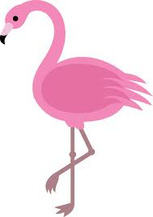
The Twelve Days of Christmas

On the first day of Christmas four flamingos flunked grade five

On the second day of Christmas Santa slowly sat on Saturn

On the third day of Christmas I thought in a thorny thicket

On the fourth day of Christmas fifteen flying frogs flew to Fiji

On the fifth day of Christmas funny food filled up Phil

On the sixth day of Christmas several swans swam south

On the seventh day of Christmas six snakes slithered on snow
On the eighth day of Christmas apes ate ailing ale

On the ninth day of Christmas numerous ninnies napped with nuns

On the tenth day of Christmas twenty tadpoles toppled tapeworm

On the eleventh day of Christmas elephants elegantly escorted eleven eggs

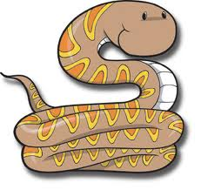
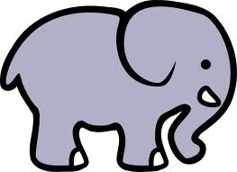
On the twelfth day of Christmas twin tanagers twisted with twine

